**AIR LINE RESERVATION SYSTEM**

# CONTRIBUTORS

AMINATU INUWA

JOSHUA ONOJA

ALAMIN BASHIR

JIMETA BELLO

# Acknowledgement

We acknowledge the support of our mentor’s and teacher’s, Mr. Sherif.

**DEDICATION**

This is dedicated to our hard work and everybody that helped in the process of creating this website, every single person who contributed like Amina, Joshua and other people.

INTRODUCTION

Our task is to design and develop an Airline Reservation System The application needs to look modern and interact with the user in an engaging way. More importantly, the main objective is to have a functional application that helps users to book and cancel flights with ease. The interface needs to be visually appealing and keep the user interested at all times. One of our guiding principles is to not give the user any opportunity to lose interest. To achieve that, we knew we had to come up with ingeniously simple solutions to huge problems. We had to be conversant with the latest web technologies and techniques.

# Challenges

The first challenge encountered was what the application was to suggest a flight to a user if the requested flight was unavailable. Feedback from the website to the user is one thing that's often overlooked, but very vital to a complete user experience. When a user tries to interact with an element, it shouldn't be a one-way affair. The element needs to communicate back to the user. For example, if the user hovers or clicks on an interact able element, the element needs to respond perhaps by changing its color or the cursor state, etc. Subtle hints like this if done correctly will add a whole new dimension to the site. However, integrating them into a consistent visual design can be very challenging indeed. We wanted an interface similar to local native applications in the sense that there are no interruptions during page transitions. No blank white interruptions. We wanted each page to just fade in quickly into an existing one as soon as it is loaded.

# Approach

The first problem of laxity was solved by group looking at other applications related to ours online. The Pages were linked specially in sections on click it would take you to a particular section on the page, this was largely due to the fact that a gallery was introduced so for easy navigation through the website pages were linked in sections.

# Architecture

The application is structured with HTML, styled with CSS and certain interactivity features were added with JavaScript. In order to not have to reinvent the wheel, the site is built on bootstrap. However, the style and behavior had to be customized significantly to get the desired result.

Some other features were added that are not used commonly like new bootstrap plug -ins. In the end a good result was produced.

# Conclusion

What we set out to develop was a well-polished user experience and to attract the user to the application. Also,

in this regard, we have definitely accomplished our objectives and overcome the obstacles with very simple solutions. We've designed not just a visual experience, but also an emotional experience for the user. In the process, we've learned so much and gained so much experience.

**SAMPLE CODE**

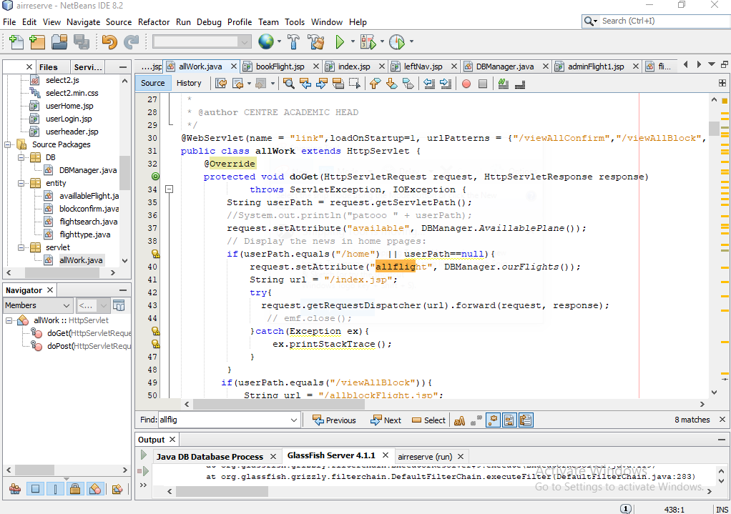

**APP SCREEN SHOTS**

**HOME**

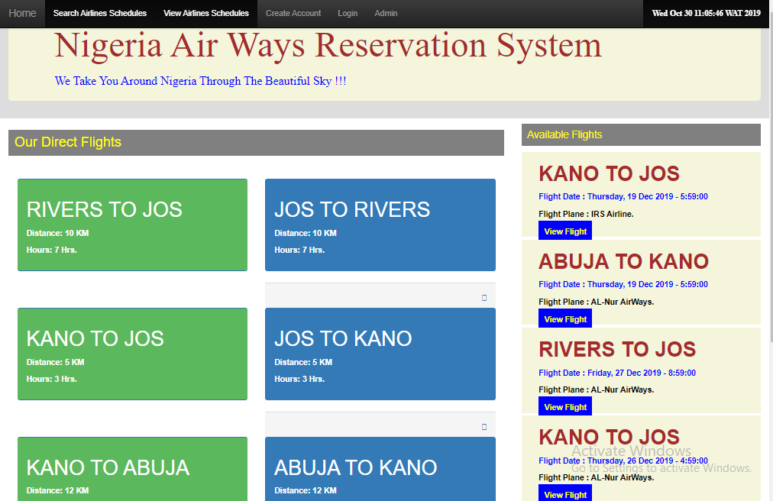

**ADMIN LOG IN PAGE**

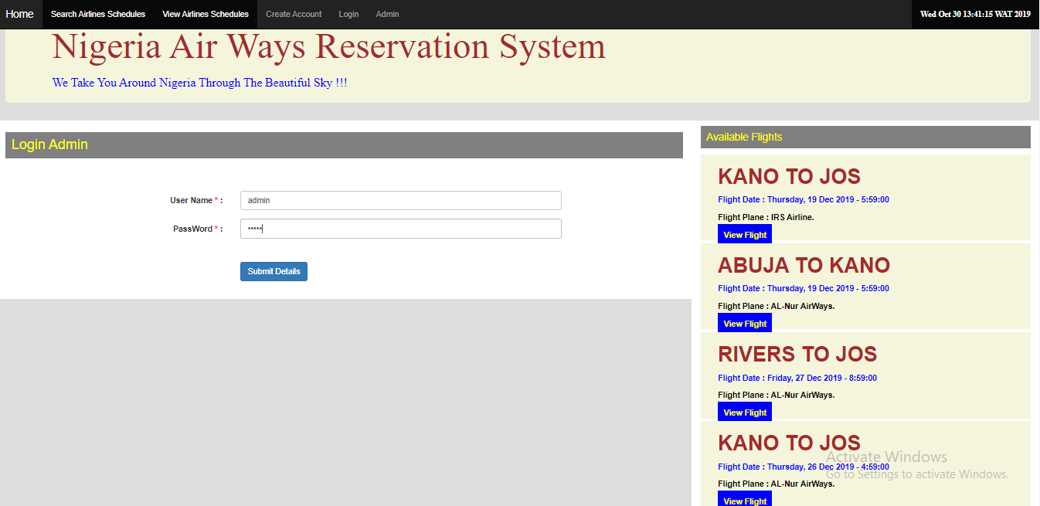

**ADMIN HOME PAGE**

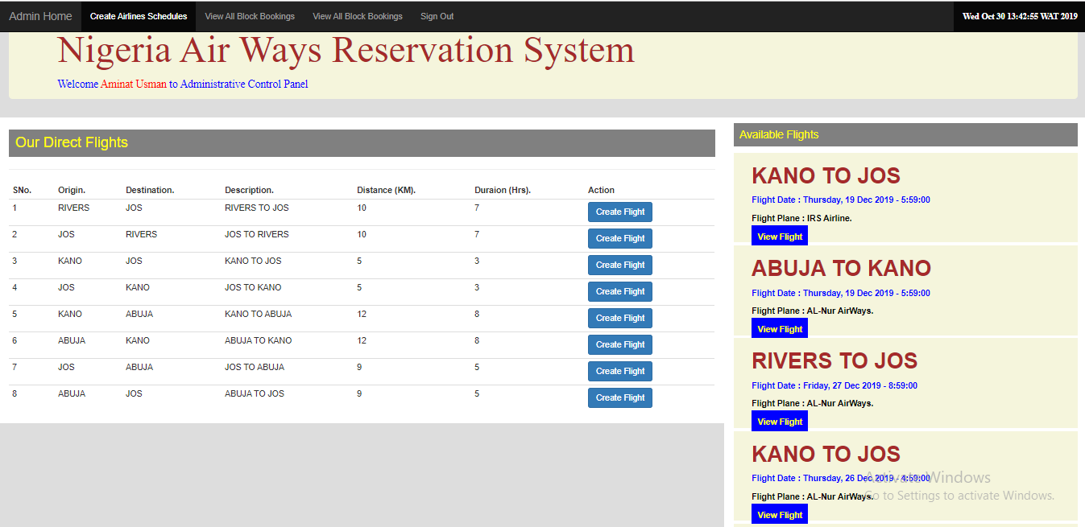

**ADMIN CREATING A FLIGHT FOR SCHEDULE PAGE**

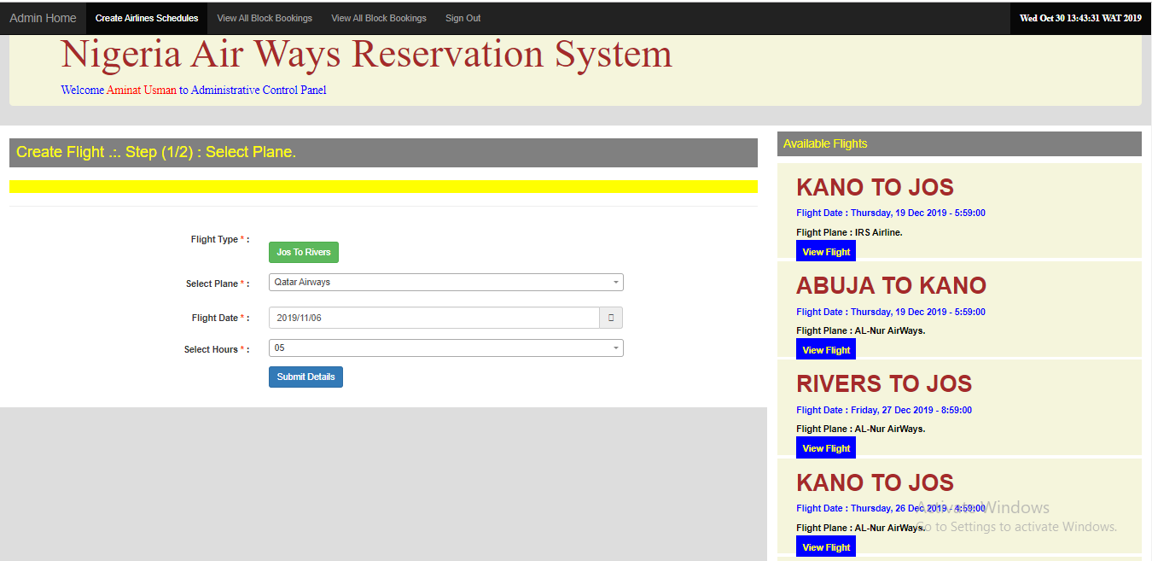

**NEW USER REGISTRATION**

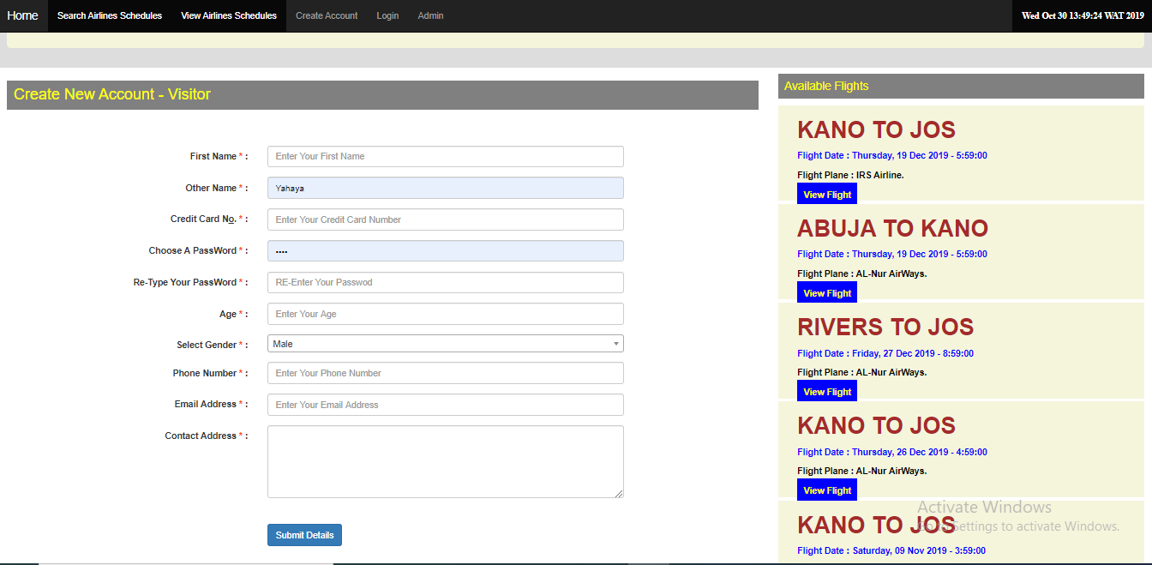

**USER LOG IN PAGE**

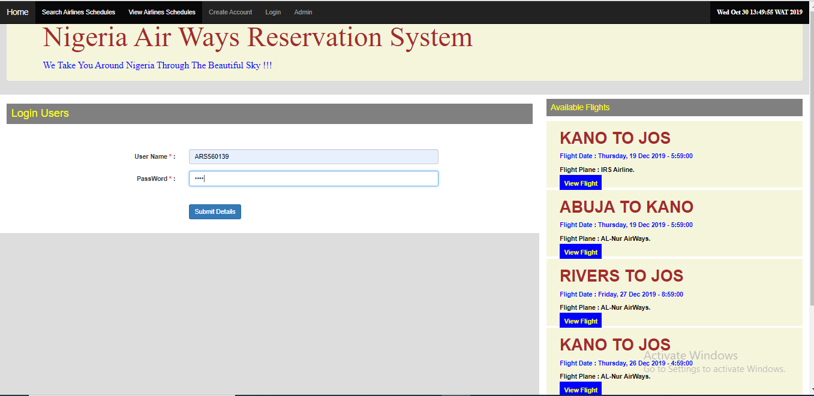

**USER ACCOUNT PROFILE PAGE**

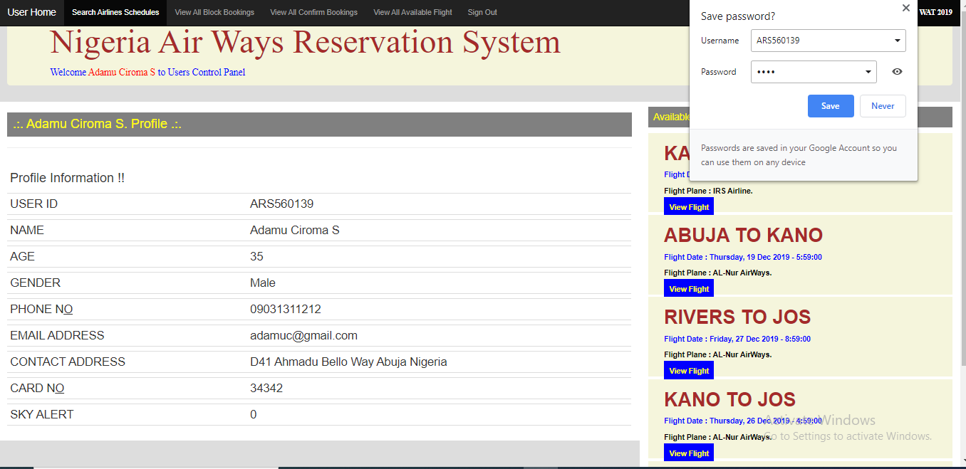

**USER SEARCH FOR AVAILABLE AIRLINE – DIRECT FLIGHT**

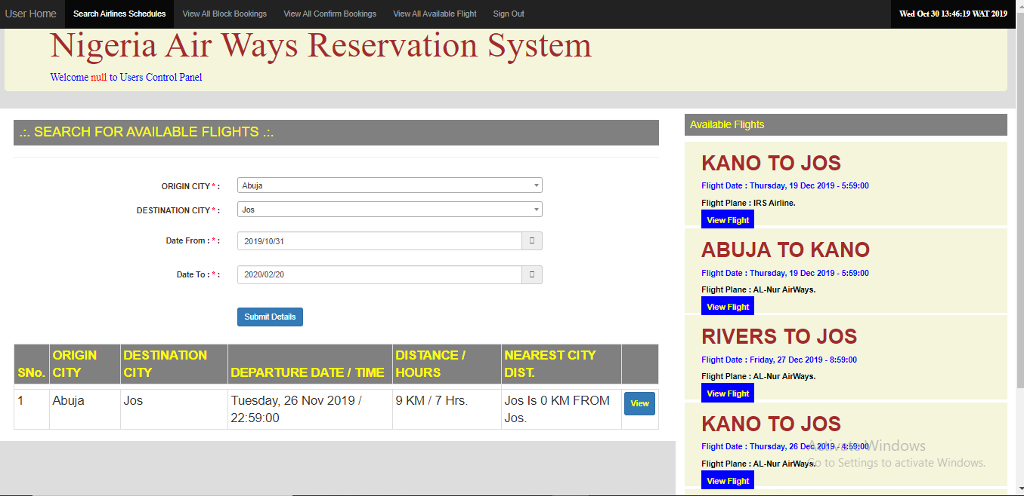

**USER SEARCH FOR AVAILABLE AIRLINE – NO DIRECT FLIGHT BUT CLOSSEST FLIGHT TO DESTINATION**

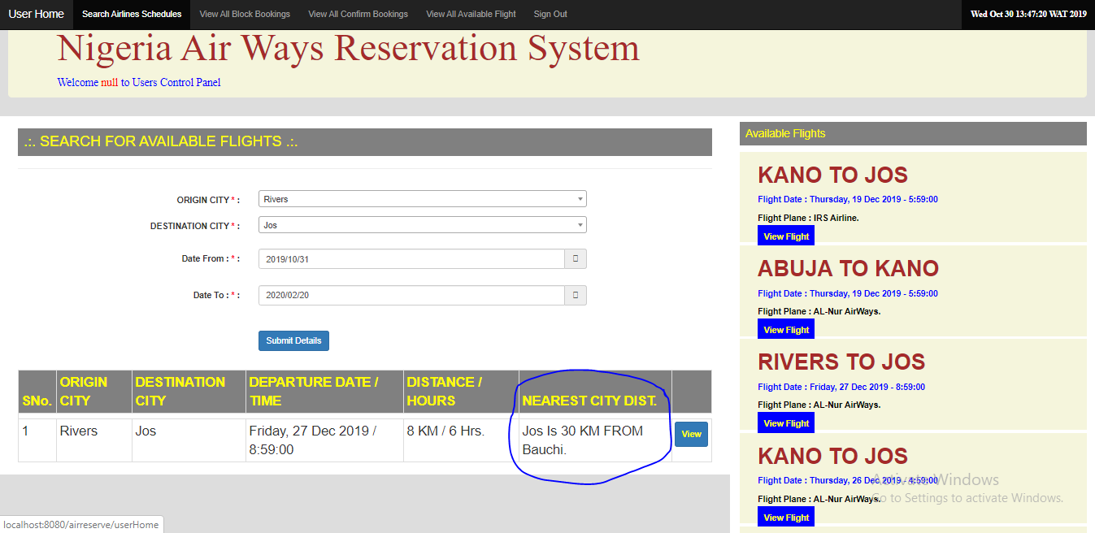

**VIEW ALL AVAILABLE AIRLINES**

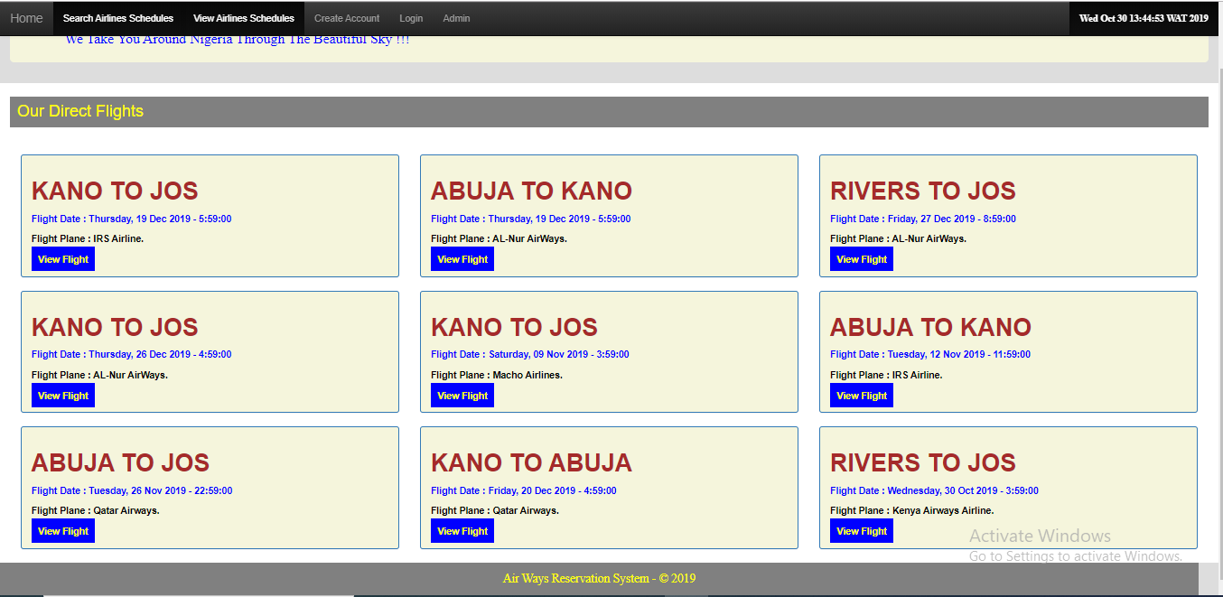

**ALL USER CONFIRM FLIGHT**

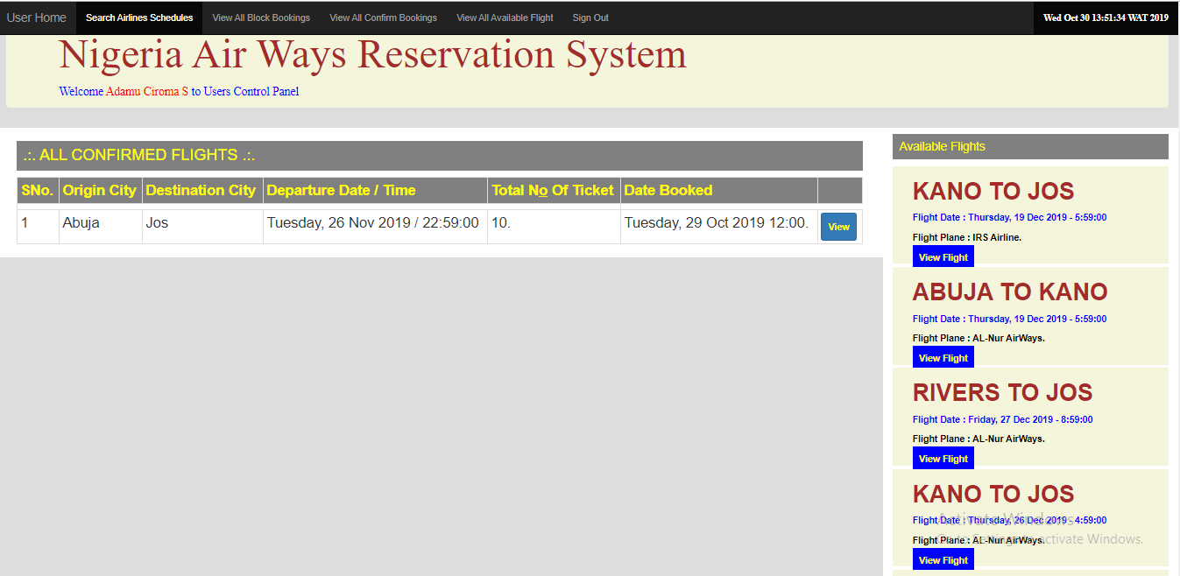

**ALL USER BLOCKED FLIGHT**

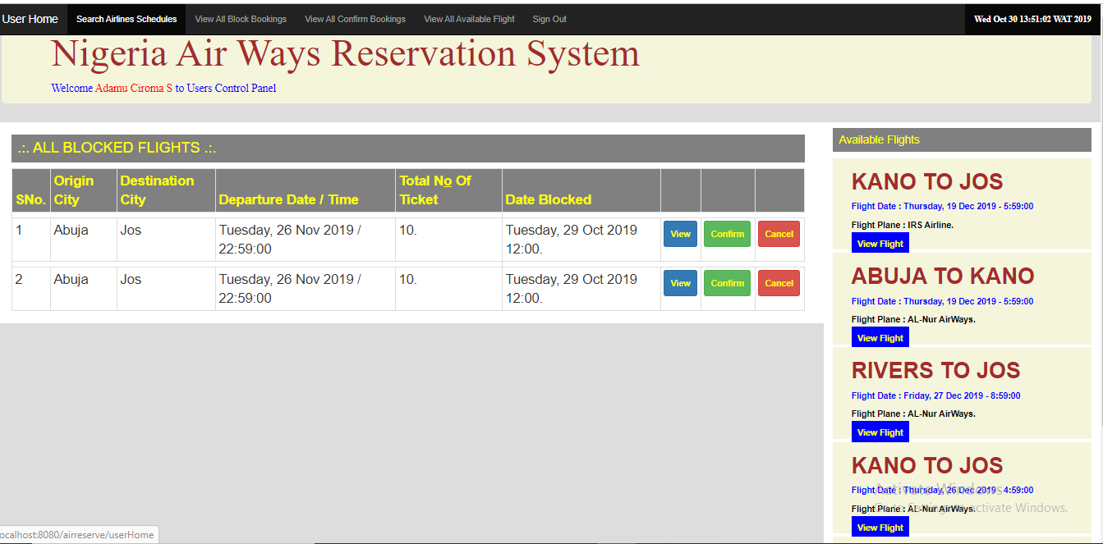

**VIEWING FLIGHT INFO BEFORE BOOKING**

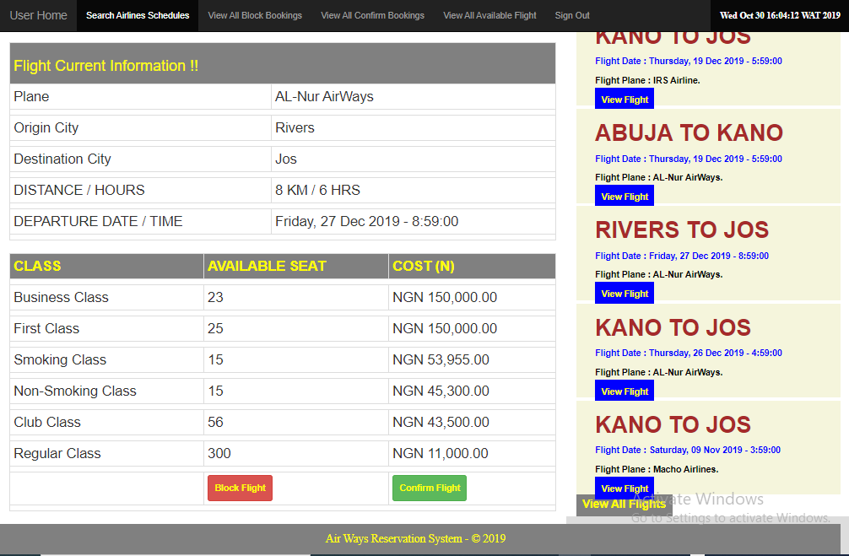

**BOOKING FLIGHT**

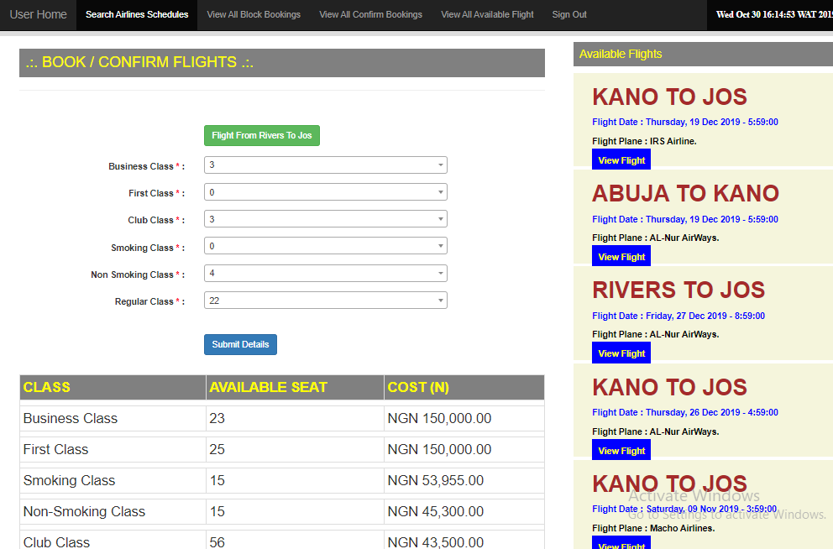

**DATABASE TABLES**

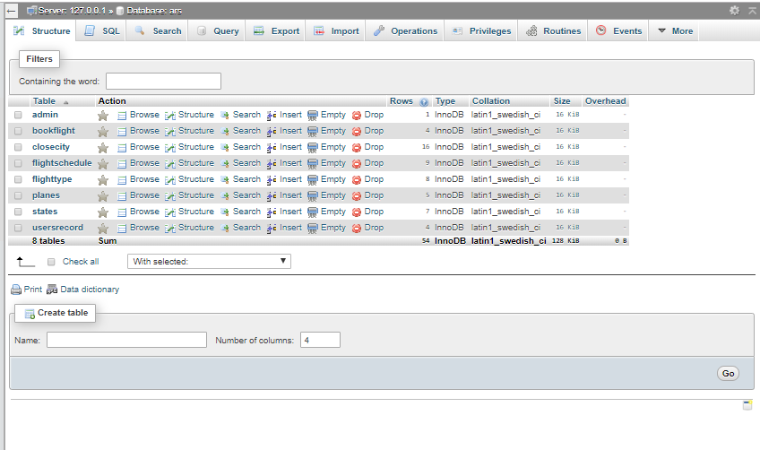

**Table : bookflight**

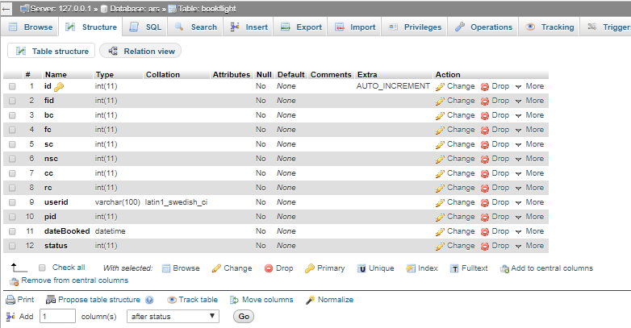

**Table: closecity**

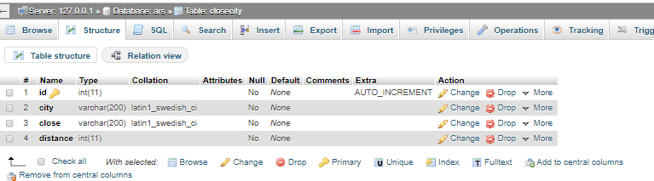

**Table: flightschedule**

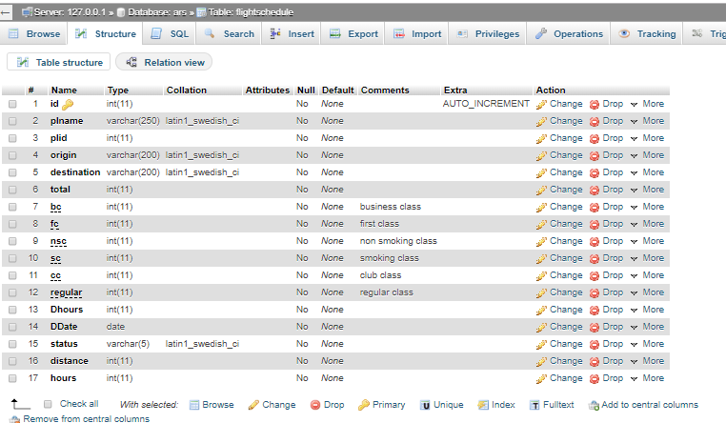

**Table: flighttype**

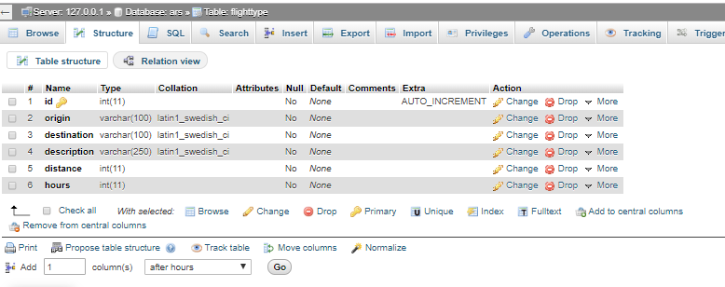

**Table: planes**

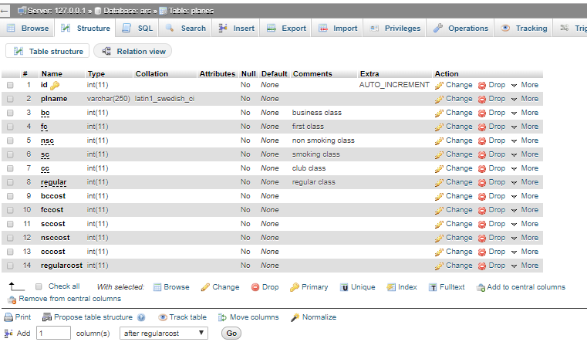

**Table: states**

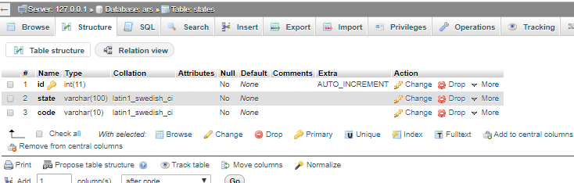

**Table: userrecords**

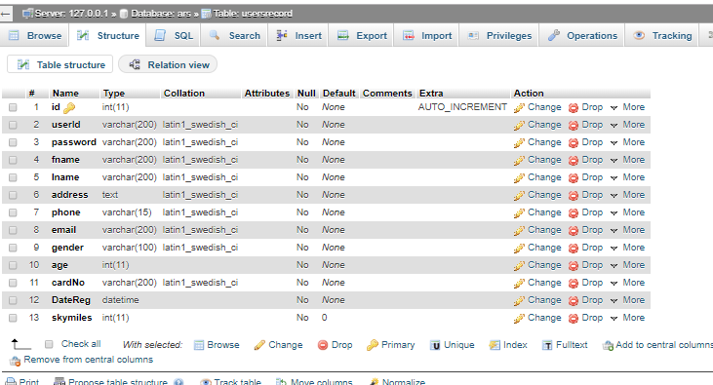

**Table:admin**

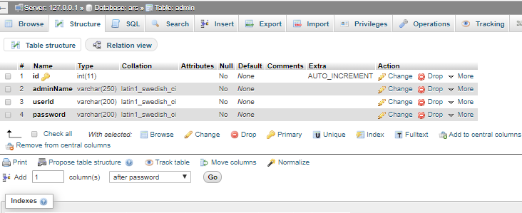

**Our servlet codes**

/*

* To change this license header, choose License Headers in Project Properties.

* To change this template file, choose Tools | Templates

* and open the template in the editor.

*/

package servlet;

import DB.DBManager;

import entity.availlableFlight;

import entity.flightsearch;

import entity.flighttype;

import entity.flighttype.allPlanes;

import java.io.IOException;

import java.io.PrintWriter;

import java.util.ArrayList;

import java.util.HashSet;

import java.util.List;

import javax.servlet.ServletException;

import javax.servlet.annotation.WebServlet;

import javax.servlet.http.HttpServlet;

import javax.servlet.http.HttpServletRequest;

import javax.servlet.http.HttpServletResponse;

import javax.servlet.http.HttpSession;

@WebServlet(name = "link",loadOnStartup=1, urlPatterns = {"/viewAllConfirm","/viewAllBlock","/confirmblock","/search","/bookflight","/userHome","/login","/register","/allflight","/home", "/saveFlight","/adminLogin","/adminHome", "/createFlight", "/loadcs", "/logout"})

public class allWork extends HttpServlet {

@Override

protected void doGet(HttpServletRequest request, HttpServletResponse response)

throws ServletException, IOException {

String userPath = request.getServletPath();

//System.out.println("patooo " + userPath);

request.setAttribute("available", DBManager.AvaillablePlane());

// Display the news in home ppages:

if(userPath.equals("/home") || userPath==null){

request.setAttribute("allflight", DBManager.ourFlights());

String url = "/index.jsp";

try{

request.getRequestDispatcher(url).forward(request, response);

// emf.close();

}catch(Exception ex){

ex.printStackTrace();

}

}

if(userPath.equals("/viewAllBlock")){

String url = "/allblockFlight.jsp";

HttpSession ses = request.getSession(false);

String adminid = ses.getAttribute("adminid").toString();

request.setAttribute("allblock", DBManager.allbookedflight(adminid));

try{

request.getRequestDispatcher(url).forward(request, response);

// emf.close();

}catch(Exception ex){

ex.printStackTrace();

}

}

if(userPath.equals("/viewAllConfirm")){

String url = "/allconfirmFlight.jsp";

HttpSession ses = request.getSession(false);

String adminid = ses.getAttribute("adminid").toString();

request.setAttribute("allconfirm", DBManager.allconfirmflight(adminid));

try{

request.getRequestDispatcher(url).forward(request, response);

// emf.close();

}catch(Exception ex){

ex.printStackTrace();

}

}

if(userPath.equals("/confirmblock")){

String id = request.getParameter("bfid");

String type = request.getParameter("type");

// System.out.println(id);

request.setAttribute("flightinfo", DBManager.getSingleFlightInfo(id));

request.setAttribute("type", type);

String url = "/bookFlight.jsp";

request.setAttribute("error", "");

try{

request.getRequestDispatcher(url).forward(request, response);

// emf.close();

}catch(Exception ex){

ex.printStackTrace();

}

}

if(userPath.equals("/bookflight")){

String id = request.getParameter("bfid");

// System.out.println(id);

request.setAttribute("flightinfo", DBManager.getSingleFlightInfo(id));

// System.out.println(DBManager.getSingleFlightInfo(id));

String url = "/flightInfo.jsp";

HttpSession ses = request.getSession(false);

if(ses.getAttribute("allinfo") != null){

url ="flightInfologin.jsp";

}

try{

request.getRequestDispatcher(url).forward(request, response);

// emf.close();

}catch(Exception ex){

ex.printStackTrace();

}

}

if(userPath.equals("/allflight")){

request.setAttribute("available", DBManager.completeAvaillablePlane());

String url = "/allflight.jsp";

HttpSession ses = request.getSession(false);

if(ses.getAttribute("allinfo") != null){

url ="allflightlogin.jsp";

}

try{

request.getRequestDispatcher(url).forward(request, response);

// emf.close();

}catch(Exception ex){

ex.printStackTrace();

}

}

if(userPath.equals("/login")){

request.setAttribute("error", "");

request.setAttribute("userid", "");

String url = "/userLogin.jsp";

try{

request.getRequestDispatcher(url).forward(request, response);

// emf.close();

}catch(Exception ex){

ex.printStackTrace();

}

}

//search for flight

if(userPath.equals("/search")){

request.setAttribute("error", "");

ArrayList<flightsearch> hh = new ArrayList<flightsearch>();

request.setAttribute("allResult",hh);

//request.setAttribute("userid", "");

String url = "/searchFlight.jsp";

HttpSession ses = request.getSession(false);

if(ses.getAttribute("allinfo") != null){

url ="/searchFlightlogin.jsp";

}

try{

request.getRequestDispatcher(url).forward(request, response);

}catch(Exception ex){

ex.printStackTrace();

}

}

if(userPath.equals("/userHome")){

String url = "/userHome.jsp";

try{

request.getRequestDispatcher(url).forward(request, response);

}catch(Exception ex){

ex.printStackTrace();

}

}

if(userPath.equals("/register")){

String url = "/regform.jsp";

request.setAttribute("error", "");

request.setAttribute("age", "");

request.setAttribute("gender", "");

request.setAttribute("phone", "");

request.setAttribute("email", "");

request.setAttribute("contact", "");

request.setAttribute("cnum", "");

request.setAttribute("fname", "");

request.setAttribute("oname", "");

try{

request.getRequestDispatcher(url).forward(request, response);

// emf.close();

}catch(Exception ex){

ex.printStackTrace();

}

}

/*admin contol statr for get request*/

if(userPath.equals("/logout")){

String url = "/home";

HttpSession ses = request.getSession(false);

ses.setAttribute("adminname", "");

ses.setAttribute("adminid", "");

ses.setAttribute("allinfo", "");

ses.invalidate();

try{

request.getRequestDispatcher(url).forward(request, response);

// emf.close();

}catch(Exception ex){

ex.printStackTrace();

}

}

if(userPath.equals("/adminLogin")){

request.setAttribute("error", "");

request.setAttribute("userid", "");

String url = "/adminLogin.jsp";

try{

request.getRequestDispatcher(url).forward(request, response);

// emf.close();

}catch(Exception ex){

ex.printStackTrace();

}

}

if(userPath.equals("/createFlight")){

String fid = request.getParameter("fid");

if(!fid.equals("")){

//int pg = Integer.parseInt(fid);

HttpSession ses = request.getSession(true);

ses.setAttribute("flightdetails", DBManager.createFlightInfo(fid));

request.setAttribute("planeinfo", DBManager.AllPlaneInfo());

request.setAttribute("fid", fid);

request.setAttribute("error","");

String url = "/adminFlight1.jsp";

try{

request.getRequestDispatcher(url).forward(request, response);

// emf.close();

}catch(Exception ex){

ex.printStackTrace();

}

}

}

/*admin contol ends*/

}

@Override

protected void doPost(HttpServletRequest request, HttpServletResponse response)

throws ServletException, IOException {

String userPath = request.getServletPath();

request.setAttribute("available", DBManager.AvaillablePlane());

if(userPath.equals("/login")){

String url = "/userLogin.jsp";

String userID= request.getParameter("userid");

String pword= request.getParameter("password");

ArrayList<String> goff = DBManager.LoginUser(userID,pword);

//System.out.println(goff);

if(goff.size()>0){

url = "/userHome.jsp";

request.setAttribute("allflight", DBManager.ourFlights());

HttpSession ses = request.getSession(true);

ses.setAttribute("adminname", goff.get(0));

ses.setAttribute("adminid", goff.get(1));

ses.setAttribute("allinfo", goff);

}else{

request.setAttribute("error", "Invalid User Name Or Password. Verifuy !!!");

request.setAttribute("userid", userID);

}

try{

request.getRequestDispatcher(url).forward(request, response);

}catch(Exception ex){

ex.printStackTrace();

}

}

//searcch flight post

if(userPath.equals("/search")){

String destination = request.getParameter("destination");

String origin = request.getParameter("origin");

String txtdatefrom = request.getParameter("txtdatefrom");

String txtdateto = request.getParameter("txtdateto");

// System.out.println(txtdatefrom + " " +txtdateto );

request.setAttribute("error","");

request.setAttribute("allResult", DBManager.searchFlightsCriteria(destination,origin,txtdatefrom,txtdateto));

//System.out.println(DBManager.searchFlightsCriteria(destination,origin,txtdatefrom,txtdateto));

//request.setAttribute("userid", "");

String url = "/searchFlight.jsp";

HttpSession ses = request.getSession(false);

if(ses.getAttribute("allinfo") != null){

url ="searchFlightlogin.jsp";

}

try{

request.getRequestDispatcher(url).forward(request, response);

// emf.close();

}catch(Exception ex){

ex.printStackTrace();

}

}

if(userPath.equals("/adminLogin")){

String url = "/adminLogin.jsp";

String userID= request.getParameter("userid");

String pword= request.getParameter("password");

ArrayList<String> goff = DBManager.LoginAdmin(userID,pword);

//System.out.println(goff);

if(goff.size()>0){

url = "/adminHome.jsp";

request.setAttribute("allflight", DBManager.ourFlights());

HttpSession ses = request.getSession(true);

ses.setAttribute("adminname", goff.get(0));

// System.out.println(goff.get(0));

ses.setAttribute("adminid", goff.get(1));

}else{

request.setAttribute("error", "Invalid User Name Or Password. Verifuy !!!");

request.setAttribute("userid", userID);

}

try{

request.getRequestDispatcher(url).forward(request, response);

}catch(Exception ex){

ex.printStackTrace();

}

}

//save the flight

if(userPath.equals("/saveFlight")){

String url = "/adminLogin.jsp";

String txtdate = request.getParameter("txtdate");

String fid = request.getParameter("fid");

String txtplane = request.getParameter("txtplane");

String txthours = request.getParameter("txthours");

HttpSession ses = request.getSession(false);

ArrayList<flighttype> flighttype =(ArrayList<flighttype>) ses.getAttribute("flightdetails");

ArrayList<allPlanes> selectedPlane = DBManager.getPlaneById(txtplane);

if(DBManager.saveFlightInfo(txthours, txtdate, flighttype,selectedPlane)){

request.setAttribute("allflight", DBManager.ourFlights());

url = "/adminHome.jsp";

}else{

request.setAttribute("error", "Invalid User Name Or Password. Verifuy !!!");

url = "/createFlight?fid=" + fid;

}

try{

request.getRequestDispatcher(url).forward(request, response);

}catch(Exception ex){

ex.printStackTrace();

}

}

//save new user

if(userPath.equals("/register")){

String url = "/regform.jsp";

request.getAttribute("error");

String age = request.getParameter("age");

String gender = request.getParameter("gender");

String phone = request.getParameter("phone");

String email = request.getParameter("email");

String contact = request.getParameter("contact");

String cnum = request.getParameter("cnum");

String fname =request.getParameter("fname");

String oname = request.getParameter("oname");

String password = request.getParameter("password");

request.setAttribute("age", age);

request.setAttribute("gender", gender);

request.setAttribute("phone", phone);

request.setAttribute("email", email);

request.setAttribute("contact",contact);

request.setAttribute("cnum",cnum);

request.setAttribute("fname", fname);

request.setAttribute("oname", oname);

// String password="1122";

String rtpassword = (String)request.getParameter("rtpassword");

// System.out.println(request.getParameter("contact"));

if(password.equals(rtpassword)){

Integer userId = (int)(Math.random() * ((900000 - 100000) + 1)) + 100000;

boolean save = DBManager.createNewUser(age,gender,phone,email,contact,

cnum,fname,oname,password,userId);

if(save){

url = "/userHome.jsp";

ArrayList<String> goff = DBManager.LoginUser("ARS"+userId.toString(),password);

HttpSession ses = request.getSession(true);

ses.setAttribute("adminname", goff.get(0));

ses.setAttribute("adminid", goff.get(1));

ses.setAttribute("allinfo", goff);

}else{

request.setAttribute("error", "Error: Unable To Create New User .. Verify!!");

}

}else{

request.setAttribute("error", "Error: Unable To Create New User .. Verify!!");

}

try{

request.getRequestDispatcher(url).forward(request, response);

// emf.close();

}catch(Exception ex){

ex.printStackTrace();

}

}

if(userPath.equals("/confirmblock")){

String fc = request.getParameter("fc");

String bc = request.getParameter("bc");

String sc = request.getParameter("sc");

String nsc = request.getParameter("nsc");

String rc = request.getParameter("rc");

String cc = request.getParameter("cc");

String planeid = request.getParameter("planeid");

String flightid = request.getParameter("flightid");

String type = request.getParameter("type");

String url = "/bookFlight.jsp";

int t = 0;

if(type.equals("block")){

t=0;

url = "/allblockFlight.jsp";

}

if(type.equals("confirm")){

t=1;

url = "/allconfirmFlight.jsp";

}

HttpSession ses = request.getSession(false);

String adminid = ses.getAttribute("adminid").toString();

// System.out.println(id);

DBManager.createBookingInfo(fc,bc,sc,nsc,rc,cc,

planeid,flightid,t,adminid);

if(type.equals("block")){

request.setAttribute("allblock", DBManager.allbookedflight(adminid));

url = "/allblockFlight.jsp";

}

if(type.equals("confirm")){

request.setAttribute("allconfirm", DBManager.allconfirmflight(adminid));

url = "/allconfirmFlight.jsp";

}

request.setAttribute("type", type);

request.setAttribute("error", "");

try{

request.getRequestDispatcher(url).forward(request, response);

// emf.close();

}catch(Exception ex){

ex.printStackTrace();

}

}

}

}